Community Development Coordinator Handbook 25/26




Content:

- Introduction
- Creating Aims
- Planning Guide
- Tracker
- Checkpoints
- End of Year Recognition
- Useful Resources

Introduction:
Last year, we introduced the SDG form and sustainable development plan to student group affiliation and processes. This year, we have revamped the project into the community development plan, which looks at approaching the project in a more accessible and personalised way.
The project looks to get student groups thinking more about how they impact their communities, whether that is internally, locally or even in regards to a wider outreach. This tracker is to be used to keep the SU in the loop of what fundraising initiatives you have put on, to keep up to date with what impact your society is making as well as to inform us when it comes to the end of year awards.
As part of the affiliation process, each student group should discuss between them who in their committee is interested in taking on being the community development coordinator (in a similar process to the election coordinators). It can be anybody who is simply passionate about the subject, but will automatically be assigned to the wellbeing and inclusion ambassador should your group not decide otherwise. If you feel there is a need to over time, you could add it as an official committee position, but it is totally up to your group's aims and needs!
It is compulsory for a student group to have a coordinator, however it requires no specific level of commitment or number of hours and is completely up to the coordinator as to what they do with the role.

Creating Aims:
There are a wide variety of topics that you could cover. It isn’t just about climate action and being sustainable, but also fundraising, advocacy, social impact and political change as well as so much more. The first job of a coordinator should be to decide upon aims for the year alongside their committee. These aims should then be put into the form as part of affiliation.

In choosing your aims, you could consider….
- What awareness or advocacy topics is your group particularly passionate about?
- If you are already working on any developments or if you want to work on an additional/new one.
- Any partnerships or connections you have with external organisations or sponsorships.
- What issues are relevant to your student group activities, aims, objectives or regular topics of discussions?
- If you are a national/cultural group, what themes or issues are prominent within your community right now?
- But also, what are you as the coordinator most interested in?
You could also use the United Nations Sustainable Development Goals as a guideline/inspiration from the last year. However, remember that you do not have to achieve the goal in its entirety, but rather contribute in one way or the other e.g. working on Goal 1: No Poverty might include organising a bake sale raising money for the local Homelessness charity which directly targets the aforementioned goal. Remember, every action could make a difference to the global struggle for sustainable development, hence every little bit counts!
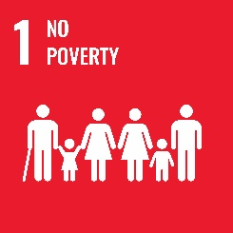
The goals are (click on the icon for more info or check the goals breakdown guide):

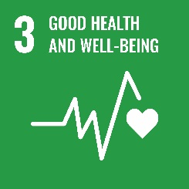
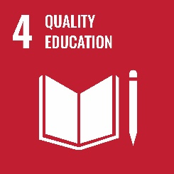
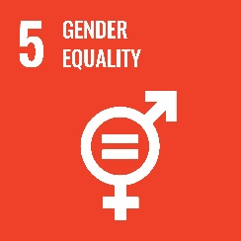
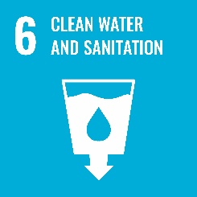


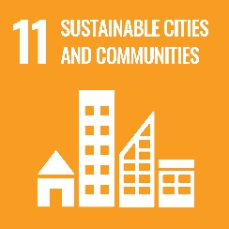
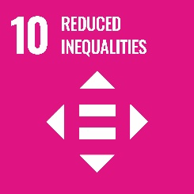

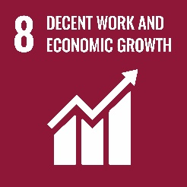
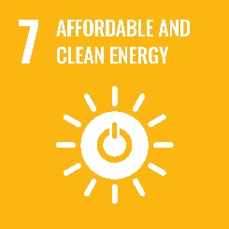

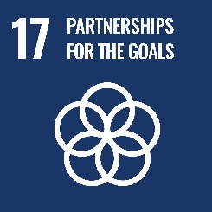

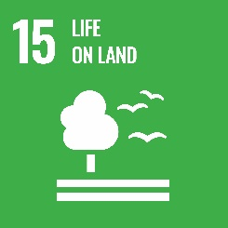
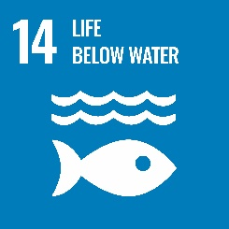


You can also check out this video that helps break things down a bit more.
It is compulsory to decide on a maximum of 3 aims depending on how much commitment you want to put in or if you feel you can work on/or already working on more.
Once you have decided and confirmed it with the rest of your committee, please fill in your community development form.

Planning Guide:
You can use the following guide to plan out how you can achieve your aims and to help spark up ideas.
Prompt
What ways are your student group already working on your aims?

Are there any world events, awareness days or issues particularly prominent within your topics that you could raise awareness of?

Do you know of any organisations, charities or campaigns working within the area that you can reach out to/fundraise for?

What sort of events could you hold both within your society and out in the wider student body/community?

In what way could your student group campaign to improve the situations within your area, or use their platform?

Who within the university or Students’ Union could you reach out to for additional support specifically within your topics?

How could your other members of committee help to support or get involved in achieving your aims?

Additional Ideas/Notes:

Examples of Previous Achievements
- Last year, SCRUBS were recognised for their work done on creating better gender equality within their field. They did this by holding a ‘Women in Surgery’ conference, supported by social media posts, that focused on discrepancies in the field and better equipping female surgeons.
- Last year, Equestrian and Polo were recognised for their fundraising efforts as supported by their submission of trackers. This way we were able to confirm how much money they raised for the Air Ambulance Service through efforts like sponsored walks and runs.
- Another example is how Women’s Football took on a sustainability goal and achieved their aim by producing reusable water bottles for training after noticing how many players were relying on single-use plastic.

Tracker:
The tracker is to be used throughout the year for keeping up with what you have done to work on your aims as well as any information you will need to share at the end of the year.
You will also need your tracker for checkpoints with the SU and for consideration in end of year award.
Aim/objective is where you can link back to your confirmation form as to which aim/objective it meets.
Please ensure it is dated and that evidence is provided/attached.
Examples of Evidence:
- Screenshots of social media posts
- Links to GoFundMe or similar donation pages
- Comparisons of any changes made to policies or processes
- Photos of any events taking place
Evidence that is NOT accepted:
- Text that is not supported by an image or document
- Photos unrelated to what is actually being said
Date | Aim/Objective  - What group or cause do you target?  - Why have you chosen this particular aim/objective?  - How relevant it is to the local community and your society in general? | How  - Provide the time frame for the achievement of your aim/objective  - Write down all of the relevant stakeholders and their contributions  - Any steps you’ve taken to achieve your aim/objective: events organised, funds raised, social media campaigns done etc. | Evidence

Checkpoints:
There will be 3 checkpoints throughout the year. One in November, a second in January and a final one in March. The checkpoint will be an email to the coordinator but can be a Teams call on request.
This way we can ensure that you’re on track to achieving your aims and objectives, plus it may be helpful to staying updated; receiving support with running events or getting general advice.

End of Year Recognition:
To celebrate every student group’s hard work and your community development achievements, there will be dedicated awards during SU awards for those who have submitted trackers and completed checkpoints.
To ensure you are recognised, please complete your checkpoints and keep the SU in the loop with any and all advancements throughout the year.
Again, this isn’t a race and any commitment level is accepted. We want you to work on your aims in a way that is right for you as well as your society, and uphold that any number of achievements are impactful.
We also want to ensure that those that do go above and beyond are recognised for their contributions and that prizes will be awarded to help those groups develop on any projects in the following year.

Useful Resources and Contact:
Resources
- UN 17 Sustainable Development Goals Main Page Website Link
- Icons, Downloads and Guidelines
- Students’ Union Committee Hub
- Goals Breakdown
- Students’ Union Sustainability Hub

