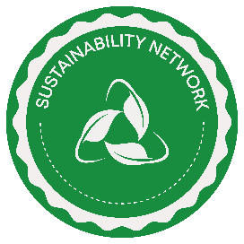 Leicester Students’ Union Sustainability Network
Sustainability Hub Resources
Go green for lazy people ideas:

- Turn off water tap when brushing teeth
- Use / bring a reusable water bottle
- Unplug your electronics at night
- Use / bring a reusable bag to the shops
- Wash your laundry in cold water
- Hang your washing out to dry
- Avoid food waste
- Lower the temperature of your heater
- Reduce, Reuse and Recycle
- Use cloth napkins instead of paper
- Watch documentaries about the food industry and environment
- Donate clothes / shop at thrift stores = sustainable fashion
- Walk, bike or use public transportation
- Reduce meat and dairy consumption
- Avoid single use plastics
- Support sustainable brands
- Drive the speed limit
- Go paperless / pay your bills online
- Avoid using generative AI tools like ChatGPT

Green washing and eco-myths ideas:

- Eco-friendly cleaning isn’t as effective
- Green cleaning products are more expensive
- All eco labels are not created equal

